Chapter 11, Solution 52.

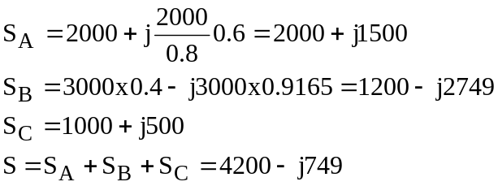

(a) 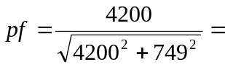0.9845 leading

(b) 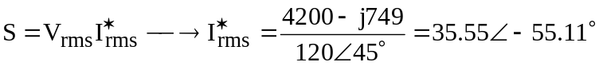

I_{rms} = 35.55∠55.11˚ A.

